**6.P.3.1 - I can illustrate the transfer of heat energy from warmer objects to cooler objects using conduction, convection and radiation.  
  
  
a) I will define convection, conduction and radiation.**

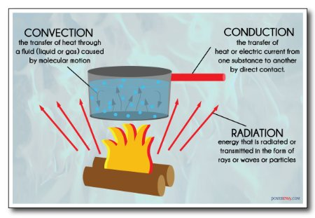

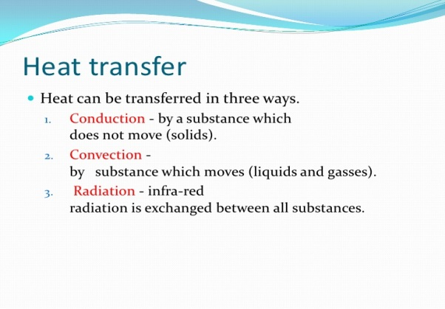

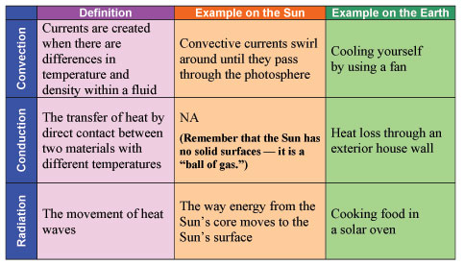

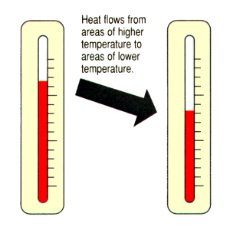

**Student Notes:**

**b) I will determine the similarities and differences between conduction, convection and radiation.**

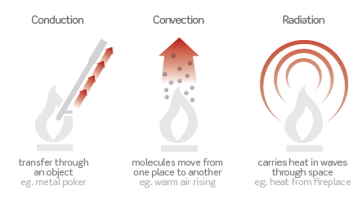

Differences:

* Convection transfers energy through the movement of molecules
* Conduction transfers energy through touch
* Radiation transfers energy through waves

Similarities:

* They all transfer heat
* Heat transfers from hot to cold
* They all have a point of equilibrium

**c) I will determine how heat flows through different materials.**

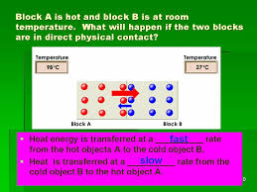

(Thermal Equilibrium - Solids)

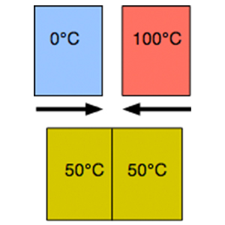

(Thermal Equilibrium - Liquids)

**Student Notes:**

**c) I will determine how heat flows through different materials.**

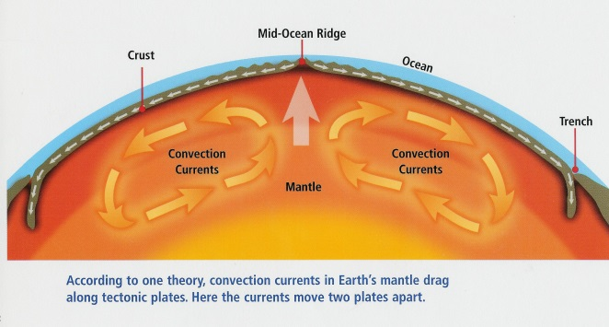

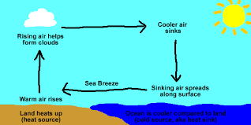

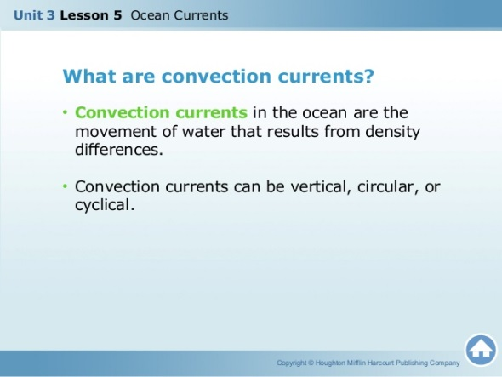

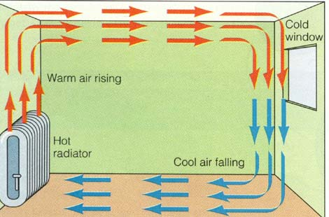

**Student Notes:**

d) I will conduct an experiment to demonstrate how heat transfers.

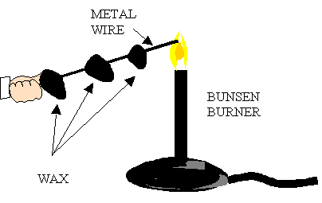

**6.P.3.2 - I can explain the effects of the electromagnetic waves on various materials to include absorption, scattering and change in temperature.**

**a) I will distinguish between reflection (scattering), diffraction and refraction.**

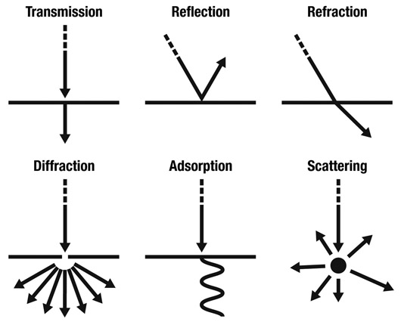

**Student Notes:**

**Electromagnetic Waves**

* Electromagnetic waves can have different wavelengths
* Some types of matter will absorb electromagnetic waves
* Some types of matter will scatter electromagnetic waves
* Electromagnetic waves can change the temperature of matter

## Absorption

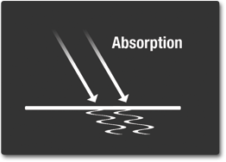

Absorption occurs when photons from incident light hit atoms and molecules and cause them to vibrate. The more an object's molecules move and vibrate, the hotter it becomes. This heat is then emitted from the object as thermal energy.

Some objects, such as darker colored objects, absorb more incident light energy than others. For example, black pavement absorbs most visible and UV energy and reflects very little, while a light- colored concrete sidewalk reflects more energy than it absorbs. Thus, the black pavement is hotter than the sidewalk on a hot summer day.

**b) I will investigate how different materials scatter, reflect, absorb light and change in temperature.**

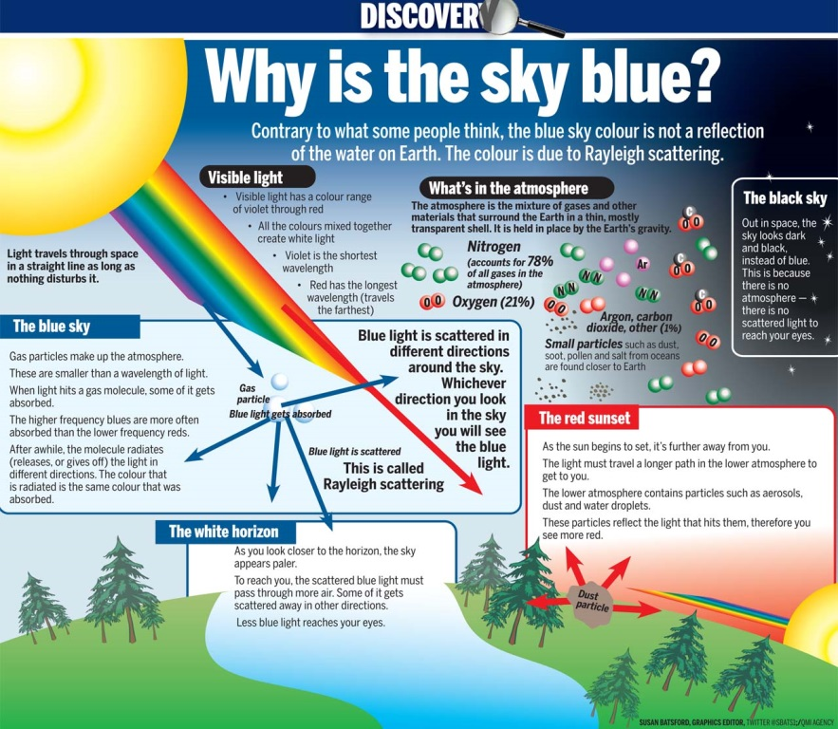

**6.P.3.3 - I can explain the suitability of materials for use in technological design based on response to heat (to include, conduction, expansion, and contraction) and electrical energy (conductors and insulators).**

**Types (Forms) of Energy Acronym - MRS CHEN**  
  
**M**echanical Energy – The sum of an objects kinetic and gravitational potential energy    
  
**R**adiant Energy (Light) – Energy produced by the vibrations of electrically charged particles.  This form of energy is easy to recognize because it gives off light.    
  
**S**ound Energy - energy caused by an object’s vibrations.  
  
**C**hemical Energy – Energy stored in the chemical bonds of a substance that can be released when the substance reacts.  Wood and oil contain energy in a chemical form. The same is true for all other material that can burn. Batteries contain chemical energy.   
  
**H**eat/Thermal Energy - This is indicated by temperature. The higher the temperature, the more energy is present in the form of heat.  Hotter objects have more particle motion!  
  
**E**lectrical Energy – Energy of moving electrons.  A generator and a battery can deliver electrical energy. The higher the voltage and the current, the more electrical energy is made available.  
  
**N**uclear Energy – Energy created when the nucleus of an atom comes together (fusion) or splits (fission).

**Student Notes:**

## Reflection

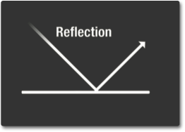

Reflection is when incident light (incoming light) hits an object and bounces off. Very smooth surfaces such as mirrors reflect almost all light.

The color of an object is actually the wavelengths of the light reflected while all other wavelengths are absorbed. Color, in this case, refers to the different wavelengths of light in the [visible light spectrum](http://missionscience.nasa.gov/ems/09_visiblelight.html) perceived by our eyes. The physical and chemical composition of matter determines which wavelength (or color) is reflected.

**a) I will give real life examples of materials that expand and contract.**



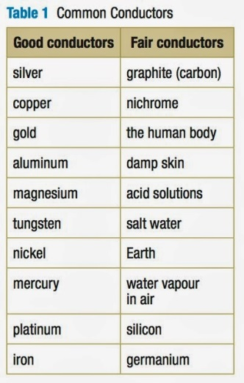 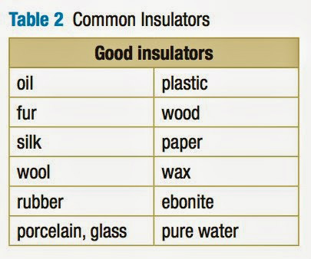

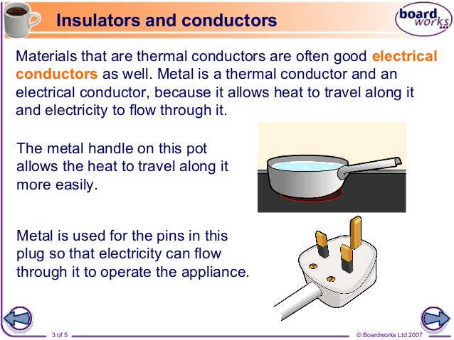

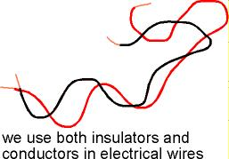 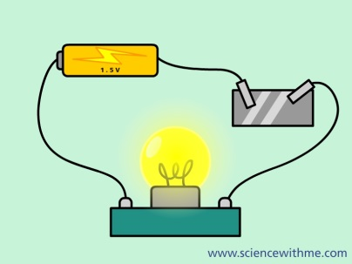

**Student Notes:**

**Conductors and Insulators**

In a **conductor**, electric current can flow freely, in an [**insulator**](http://hyperphysics.phy-astr.gsu.edu/hbase/electric/conins.html#c2#c2) it cannot.

Metals such as copper typify conductors, while most non-metallic solids are said to be good insulators, having extremely high resistance to the flow of charge through them.

"**Conductor**" implies that the [outer electrons](http://hyperphysics.phy-astr.gsu.edu/hbase/solids/sili.html#c5) of the atoms are loosely bound and free to move through the material.

Most atoms hold on to their electrons tightly and are **insulators**. In copper, the valence electrons are essentially free and strongly repel each other. Any external influence which moves one of them will cause a repulsion of other electrons which propagates, "domino fashion" through the conductor.

**Simply stated, most** [**metals**](http://hyperphysics.phy-astr.gsu.edu/hbase/pertab/metal.html#c1) **are good electrical conductors, most nonmetals are not. Metals are also generally good** [**heat conductors**](http://hyperphysics.phy-astr.gsu.edu/hbase/thermo/thercond.html#c1) **while nonmetals are not.**

Electricity will always take the shortest path to the ground. Your body is 60% water and that makes you a good **conductor** of electricity. The rubber or plastic on an electrical cord provides an **insulator** for the wires. By covering the wires, the electricity cannot go through the rubber and is forced to follow the path on the aluminum or copper wires.

**a) I will give real life examples of materials that expand and contract.**

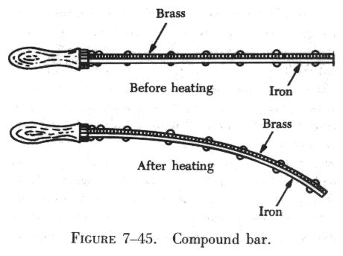 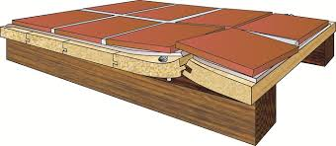

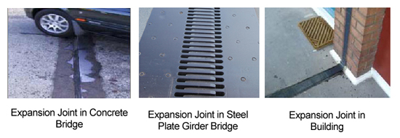

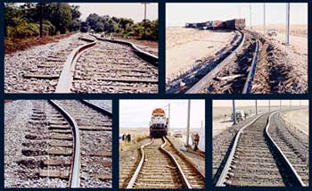

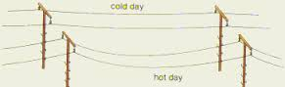

**b) I will define conduction, expansion and contraction in relationship to matter.**

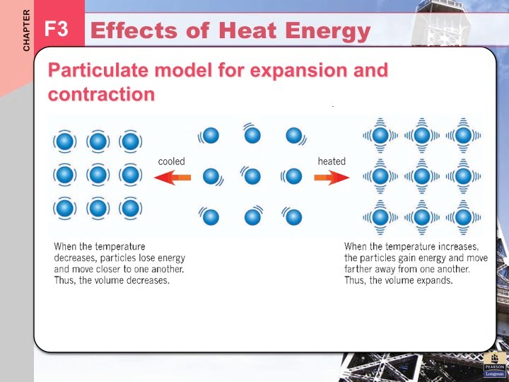

**Student Notes:**