1.What type of electromagnetic wave can be seen through thermal energy cameras?  - Infrared  - Ultraviolet  - Visible Light  - Radiation  2. It is very hot during the summer, so you want to go to your local pool. The meteorologist explains that the UV index for the day is extremely high. What does the UV index represent?  A.The UV index represents the speed of the ultraviolet rays  B.The UV index represents the intensity of ultraviolet rays  C. The UV index represents the color of the ultraviolet rays  D.The UV index represents the wavelength of the ultraviolet rays  3. Energy is transferred from the sun to Earth mainly by _______________.  - Sound Waves  - Air Currents  - Electromagnetic waves  - Compressional Waves  4. The _______________ determines the color of visible light.  - Wavelength  - Speed  - Amplitude  - Light  8. Two children on a playground are playing outside in the sun. One child is wearing a black shirt and the other is wearing a white shirt. Why is the black shirt warmer than the white shirt?  - The child wearing the black shirt is warmer than the child wearing the white shirt  - The child wearing the white shirt is warmer than the child wearing the black shirt  - The white shirt absorbs more visible electromagnetic waves than the black, which reflects all visible electromagnetic waves  - The black shirt absorbs more visible electromagnetic waves than the white, which reflects all visible electromagnetic waves.  9. How are electromagnetic waves different from other waves?  - They have very short wavelengths  - They transmit energy instead of matter  - They can travel through a vacuum  - They can change direction by reflection  10. What does the image below represent?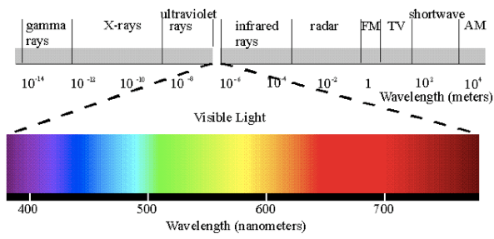  - Color Spectrum  - Electromagnetic Spectrum  - Light Reflection  - Absorption of Energy | 5. The _______________ is a major source of energy on Earth.  - Moon  - Sun  - Stars  - Earth’s Core  6. The light from the laser below is an example of what?  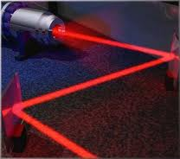  - Reflection  - Refraction  - Radiation  - Light Absorption  7. Which is not a factor that will increase an object’s temperature?  - Increasing the intensity of the light shining on it  - Increasing the length of time  - The amount of light reflected  - Amount of light absorption  Cumulative Review  11. The main method of heat transfer occurring within water is called __________  - conduction  - convection  - radiation  - insulation  12. You walk onto the beach and immediately your feet are burning. Which form of thermal energy caused the sand to heat up?  - Radiation  - Chemical  - Mechanical  - Kinetic  13. What kind of energy does a moving baseball have?  - Electrical  - Magnetic  - Mechanical  - Chemical  14. A thermometer shows that the outside air temperature is colder than the temperature at which water turns to ice. However, ice on the sidewalk melts. What probably caused this?  - The air heating the sidewalk  - The sidewalk reflecting sunlight into the air  - The wind causing the ice on the sidewalk to melt  - The sunlight making the sidewalk warmer than the air

15. What is the primary way energy is transferred when an object is plugged into a wall.

- Thermally
- Electromagnetically
- Mechanically
- Electrically

